Application: Image Processing System Using Master Theorem
Course Outcome Assessment – I
CSA0619 – DESIGN AND ANALYSIS OF ALGORITHMS
Submitted by

M Yasodha Krishna (192472100)
Under the Supervision of

Dr. F. Mary Harin Fernandez

ABSTRACT
Image processing applications often divide large images into smaller sub-images to improve processing efficiency. Recursive algorithms based on the divide-and-conquer technique are commonly used for image filtering, segmentation, compression, and enhancement. This report analyzes an image processing algorithm represented by the recurrence relation T(n) = 4T(n/2) + n using the Master Theorem. The appropriate case of the theorem is identified, and the time complexity is derived. The report also examines how the algorithm's performance changes as the image size increases.

INTRODUCTION
Modern image processing systems handle high-resolution images that require efficient algorithms for fast computation. Divide-and-conquer is a popular strategy in which an image is recursively divided into smaller regions for processing. The efficiency of such recursive algorithms is analyzed using recurrence relations. The Master Theorem provides a systematic method for solving these recurrences and determining the asymptotic running time of divide-and-conquer algorithms.

PROBLEM STATEMENT
An image processing algorithm recursively divides an image into four sub-images, each of half the original size. Additional linear work is performed at every recursive level. The recurrence relation is given by
T(n) = 4T(n/2) + n
Apply the Master Theorem to determine the time complexity, identify the appropriate parameters, select the correct case, and analyze the algorithm's performance for increasing image sizes.

OBJECTIVES
- To understand the divide-and-conquer technique used in image processing.
- To apply the Master Theorem for solving recurrence relations.
- To identify the values of a, b, and f(n).
- To determine the algorithm's asymptotic complexity.
- To analyze the performance of the algorithm for large image datasets.

SYSTEM DESCRIPTION
The image processing system recursively divides the original image into four equal regions. Each sub-image is processed independently using the same algorithm. After processing, a linear amount of work is required to combine the results. This recursive structure is represented by the recurrence relation T(n) = 4T(n/2) + n, where the recursive calls dominate the computation.

MASTER THEOREM ANALYSIS
Given the recurrence,
$$T(n)=4T(n/2)+n$$
Step 1: Identify Parameters
- a = 4
- b = 2
- f(n) = n

Step 2: Compute
$$n^{{log⁡}_{b}a} \\ =n^{{log⁡}_{2}4} \\ =n^{2}$$

Step 3: Compare
$$f(n)=n$$
with
$$n^{{log⁡}_{b}a}=n^{2}$$
Since
$$n=O(n^{2-ε})$$
for some ε > 0,
Master Theorem Case 1 applies.

Step 4: Final Complexity
According to Case 1,
$$T(n)=Θ(n^{{log⁡}_{b}a})$$
Therefore,
$$\boxed{T(n)=Θ(n^{2})}$$

IMPLEMENTATION

def image_processing(n):
if n <= 1:
return

print("Processing Image Size:", n)

for i in range(4):
image_processing(n // 2)

print("Linear Processing Work =", n)

n = int(input("Enter image size: "))
image_processing(n)

Sample Input
16

Sample Output
Enter image size: 16

Processing Image Size: 16
Processing Image Size: 8
Processing Image Size: 4
Processing Image Size: 2
Linear Processing Work = 2
...
Linear Processing Work = 16
(The output is abbreviated because the recursive calls generate many lines.)

Output Screenshot
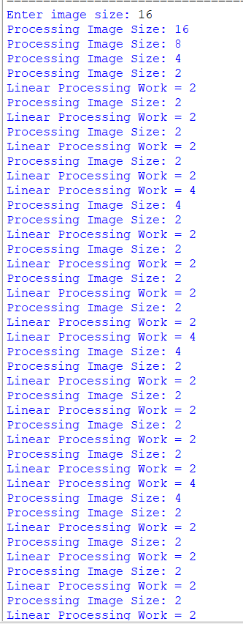
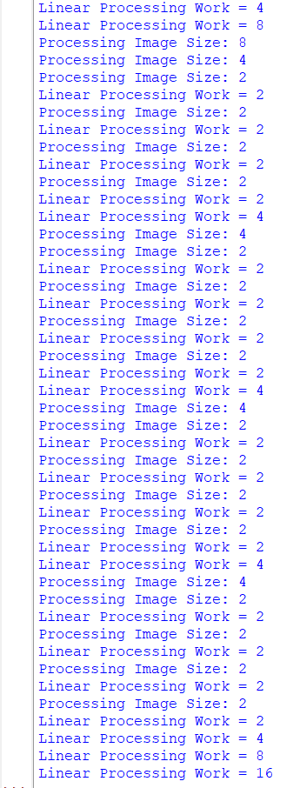

Source Code Screenshot
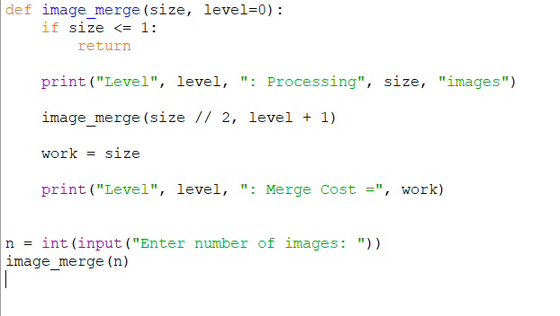

RESULT ANALYSIS
The algorithm recursively creates four subproblems of half the original image size. Although only linear work is performed at each recursive level, the large number of recursive calls significantly increases the total execution time. The recursive computation dominates the running time, resulting in quadratic growth. Therefore, as the image size increases, the execution time increases rapidly.

COMPLEXITY ANALYSIS
Parameter | Value
a | 4
b | 2
f(n) | n
log₂4 | 2
Master Theorem Case | Case 1
Time Complexity | Θ(n²)
Space Complexity | Θ(log n)

APPLICATIONS
- Digital image processing
- Medical image analysis
- Satellite image processing
- Image segmentation
- Computer vision
- Pattern recognition

ADVANTAGES
- Efficient divide-and-conquer strategy.
- Suitable for parallel image processing.
- Simple recursive implementation.
- Easy complexity analysis using the Master Theorem.

LIMITATIONS
- Large number of recursive calls.
- Higher execution time for large image sizes.
- Increased memory usage due to recursion.

CONCLUSION
The recurrence relation T(n) = 4T(n/2) + n was successfully analyzed using the Master Theorem. By identifying a = 4, b = 2, and f(n) = n, the recurrence satisfies Case 1 of the Master Theorem. Therefore, the overall time complexity is Θ(n²). As the image size increases, the execution time grows quadratically, making the algorithm suitable for moderate-sized datasets but more computationally expensive for very large images.

REFERENCES
- Thomas H. Cormen, Introduction to Algorithms, MIT Press.
- Ellis Horowitz and Sartaj Sahni, Fundamentals of Computer Algorithms.
- Alfred V. Aho, John E. Hopcroft, and Jeffrey D. Ullman, The Design and Analysis of Computer Algorithms.
- Course Notes on Design and Analysis of Algorithms.

